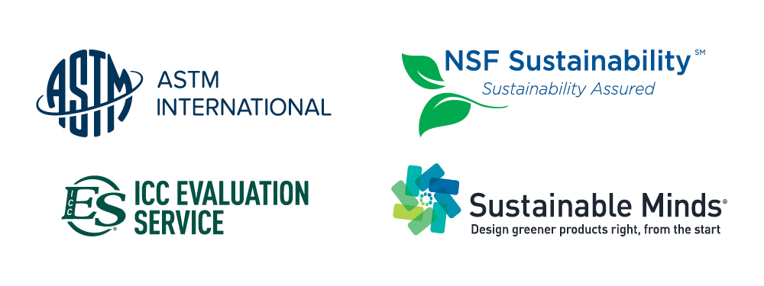

First Program Operator Consortium Launched for Environmental Product Declarations Market at Greenbuild 2015

WASHINGTON, November 17, 2015—On Wednesday, four key green-building stakeholder organizations (ASTM International, ICC Evaluation Service, NSF International and Sustainable Minds) will launch the first Program Operator Consortium in the industry. The signing will take place at Greenbuild 2015 at the ASTM International booth (#3313) at 10:30 a.m.

The consortium will serve as an expert resource and advocate for creating product category rules (PCRs), reviewing life cycle assessment (LCA) reports, and verifying and publishing environmental product declarations (EPDs). The consortium members will pool resources, leverage existing relationships, jointly conduct outreach, marketing, education and communications, and promote the overall use of PCRs, LCAs and EPDs in the marketplace.

Manufacturers, design professionals and others will begin to see co-branded, verified EPDs from the consortium members, providing value to decision makers when specifying materials and products while helping manufacturers gain greater visibility for their product transparency work.

“When an architect or another specifier is choosing which products to use, ICC-ES and our partners in this effort want them to recognize that a high-profile group is now linked together, providing instantly recognizable value in the marketplace,” says Shahin Moinian, president, ICC Evaluation Service. “This partnership just makes sense.”

“By working collaboratively, we can more effectively educate manufacturers and other design professionals about the overall value of PCRs, LCAs and EPDs,” says Dr. Lori Bestervelt, executive vice president and chief technical officer, NSF International. “That helps us strengthen our relationships, build new ones, and – just as importantly – support sustainability on an even larger scale.”

“With the proliferation of program operators, complex reporting requirements, and increased demand for these services, we saw the potential to deliver real and measurable value to manufacturers by launching this consortium,” says Terry Swack, founder and CEO of Sustainable Minds, a cloud software and services company that provides greener product design and marketing solutions. “This consortium can create uniformity that will significantly reduce market confusion.”

“All four of our organizations have a global reach, so we are collectively poised to act as a clearinghouse for best practices,” says Kathie Morgan, executive vice president, ASTM International. “Together, we can quickly meet needs and answer questions of all stakeholders. This is a clear win-win for industry.”

The four Program Operators conform with ISO 14025-Environmental Labels and Declarations-Type III Environmental Declarations – Principles and Procedures.

ICC-ES (Booth #3310)
Contact: Shahin Moinian, President, ICC Evaluation Service, tel +1.562.699.0543, smoinian@icc-es.org, www.icc-es.org
NSF International (Booth #3428)
Contact: Diane Haworth, Sr. Marketing Manager, tel +1.734.214.6202, dhaworth@nsf.org, www.nsf.org
Sustainable Minds (Booth #3552)
Contact: Terry Swack, Founder and CEO, tel +1.617.877.5416, terry@sustainableminds.com, www.sustainableminds.com
ASTM International (Booth #3313)
Contact: Brian Meincke, Assistant Vice President, Business Development, tel +1.610.832.9613, bmeincke@astm.org, www.astm.org

Media Inquiries: Nathan Osburn, Director, Corporate Communications, ASTM International, tel +1.610.832.9603, nosburn@astm.org

